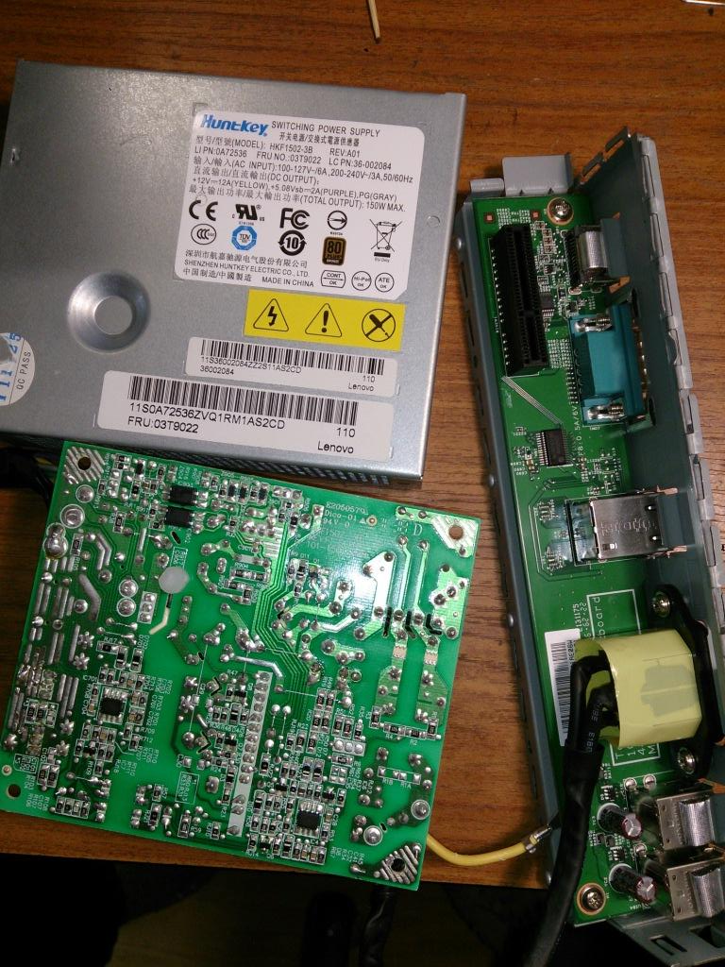
Febkbp
L.M
393m
NT75002S
122 J05A3G
PC718

