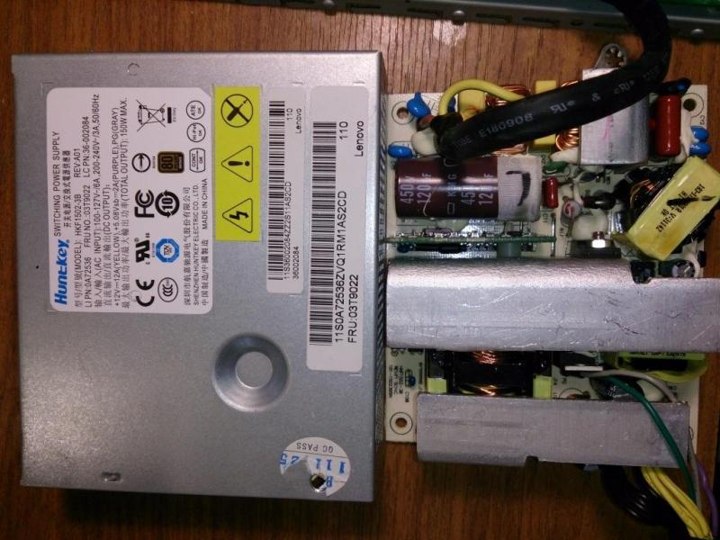
Tea1713t
Oe5c21c5s606
HnD11241
Febkbp
L.M
393m

