NF650iUltra mainboards only
Step 1: Download the NVIDIA System Utility in Albatron website.
1. Go to the Albatron website: http://www.albatron.com.tw
2. Move your mouse pointer to the "Product INFO" tab and then click the "Mainboard" item in the drop-down menu.
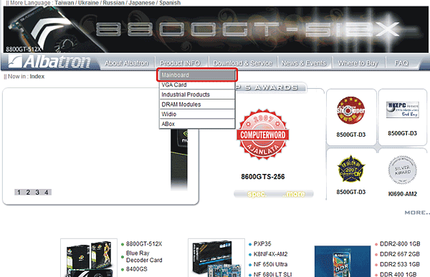
3. Select an NVIDIA Series mainboard. The example here is "NF 680i SLI" mainboard.
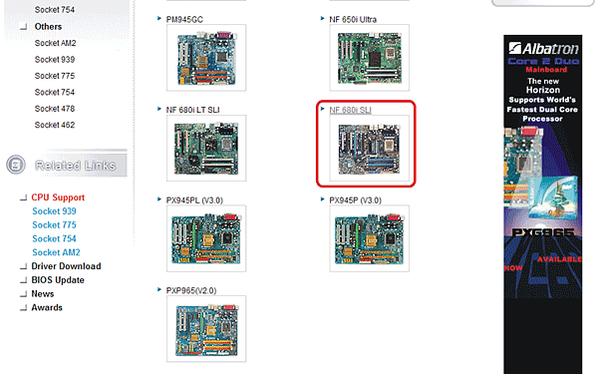
4. Click "Driver" as shown below on the left panel. Click the download icon to download the NVIDIA System Utility.
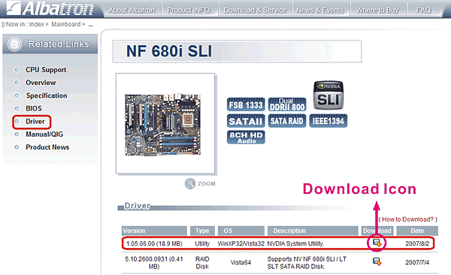
5. Press "Save" button to download the NVIDIA System Utility zip file. You must unzip the file and save the files to your computer.
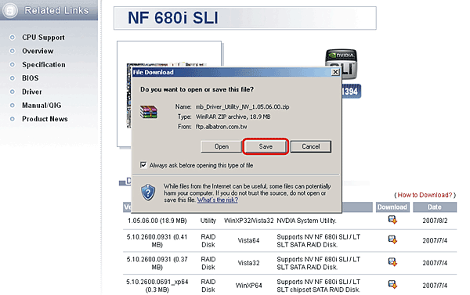
Step 2: Click the NVIDIA System Utility to start the installation.
1. When the installation starts, you will see the welcome page shown as below. Press the "Next" button to continue.
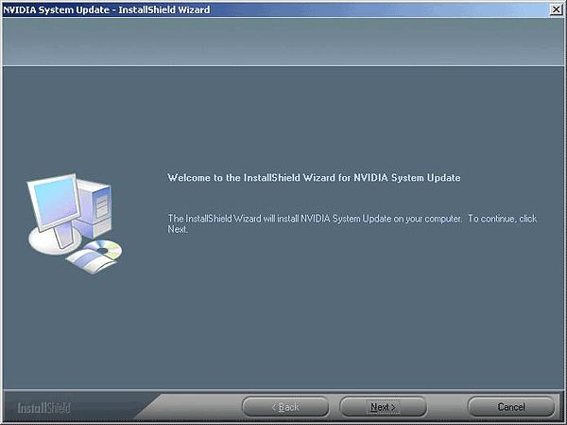
2. The next screen is the License Agreement page. After you read it, press the "Yes" button to enter the next page.
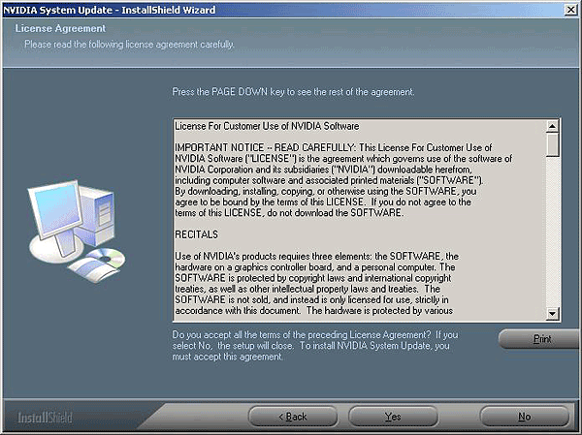
3. Select the destination folder where you want to install the files. Press the "Next" button to continue.
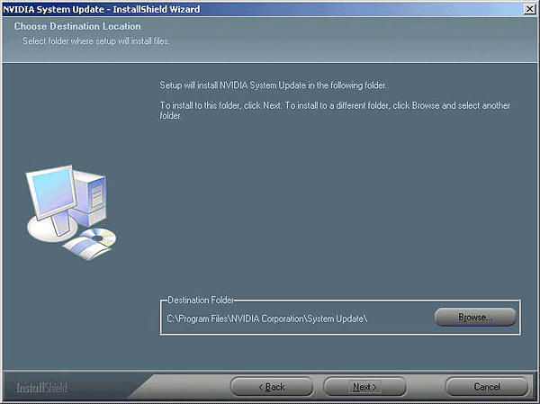
4. Now you have installed the NVIDIA System Utility onto your computer. Click the "Finish" button to quit.
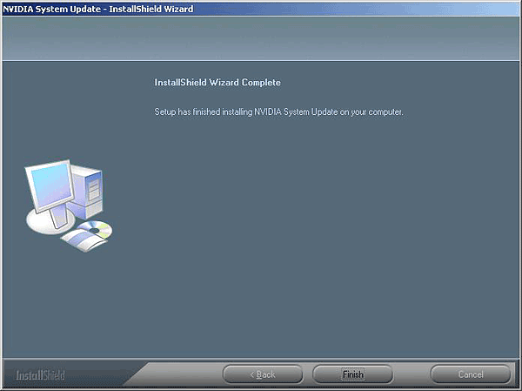
Step 3: Go back to the mainboard page as shown below.
1. Click "BIOS" as shown below on the left panel. Click the download icon to download the latest BIOS. (It all depends.)
2. Unzip the downloaded file and save the files to your computer in a designated folder.
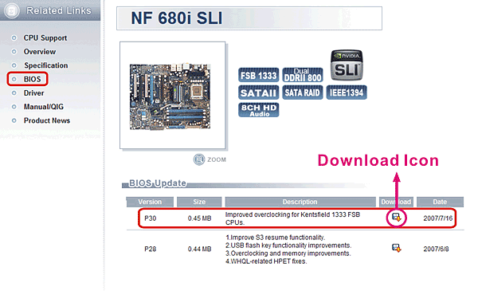
Step 4: Starting the BIOS update on the Windows Operating System.
1. Open the NVIDIA Control Panel.
{ Start } => { Programs } => { NVIDIA Corporation } => { NVIDIA Control Panel } => { System Update }
2. Click "Manage your system BIOS" as shown below on the left panel.
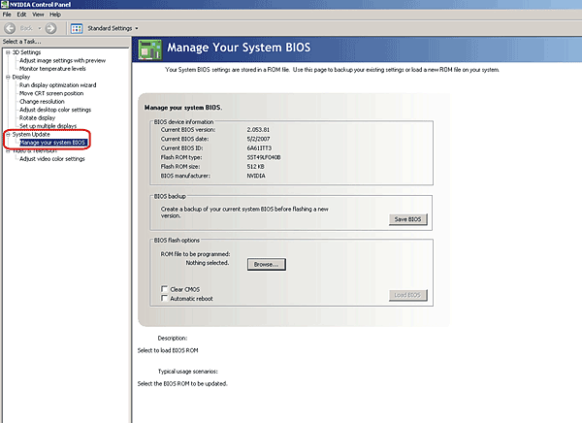
3. Before updating to the new BIOS, you can backup the current system BIOS by clicking "Save BIOS" as shown below.
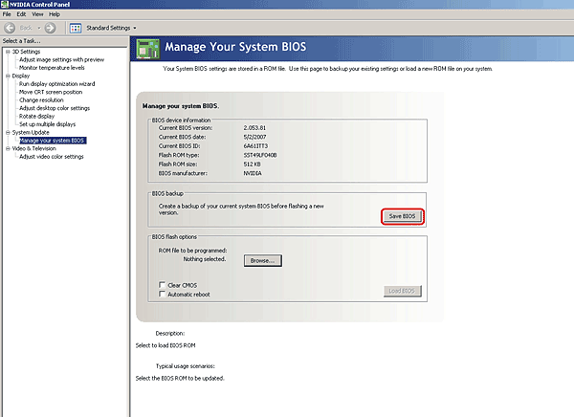
4. On the next pop-up screen, select a folder and click "Save" to backup the current system BIOS.
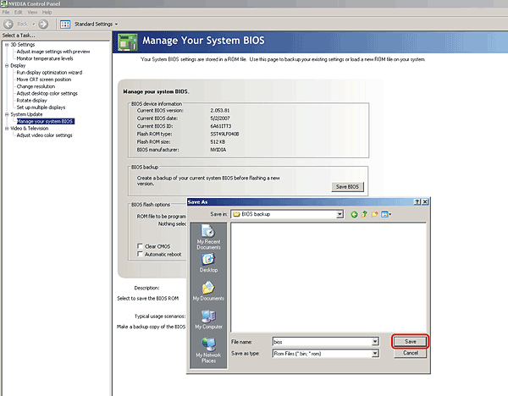
5. Click "OK" on the confirmation box below.
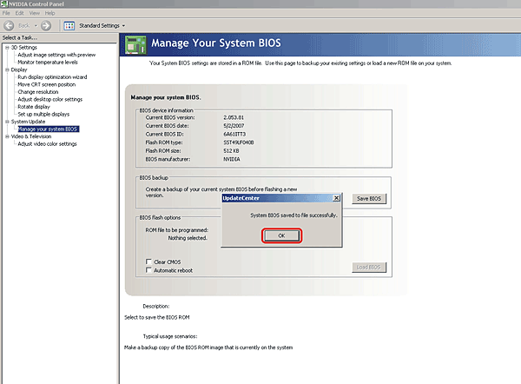
6. Next, click "Browse" to open the folder you saved the latest BIOS file to (Step 3).
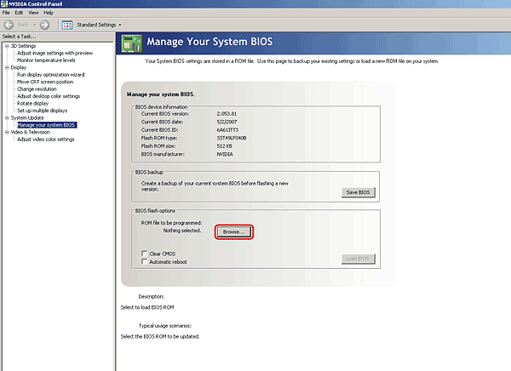
7. Select the BIOS file that you downloaded and press "Open" to continue.
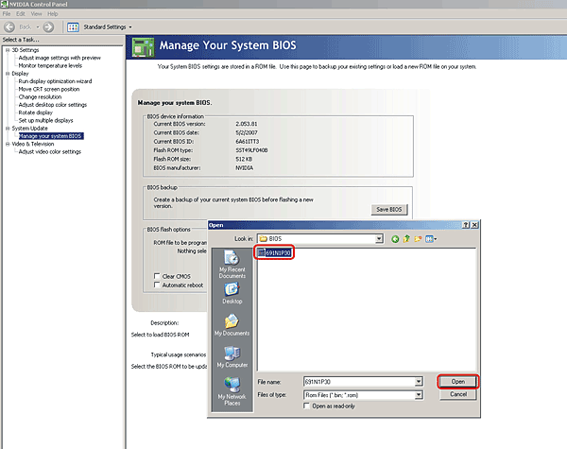
8. Make sure that both "Clear CMOS" and "Automatic reboot" items are checked.
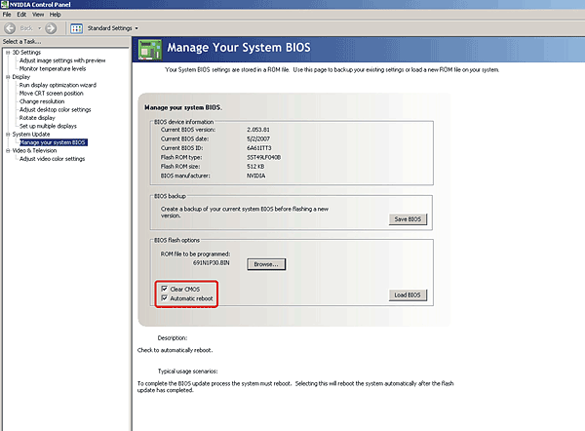
9. Then click "Load BIOS" to start the BIOS flash update.
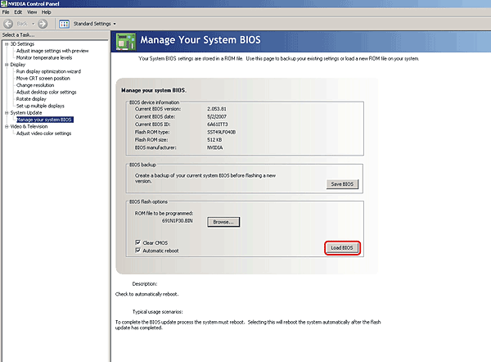
10. After the warning box shows as below. Press "Yes" to continue the BIOS flash update.
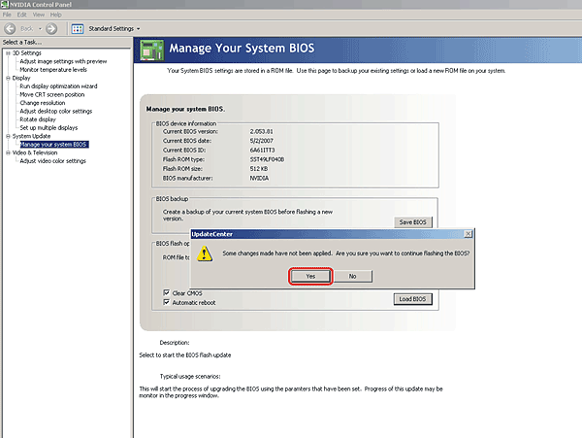
11. A pop-up box will appear to notify you that the BIOS update will take a while. Press "Yes" to continue with the BIOS flash update.
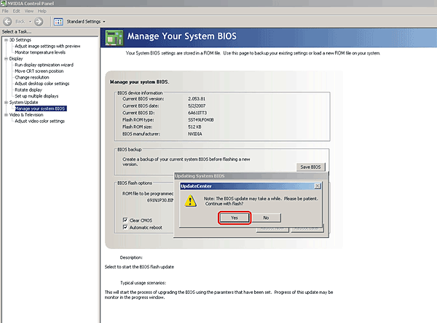
12. A pop-up box will display to notify you that the BIOS was updated successfully. It is recommended that you press the "Shutdown Now" button.
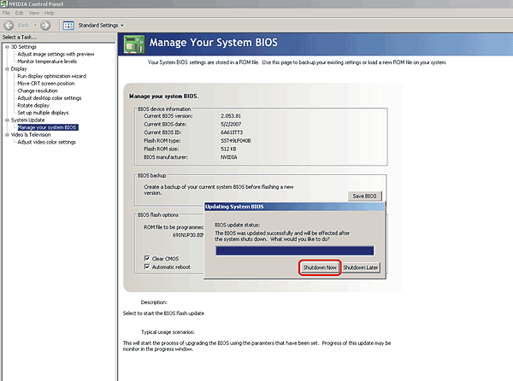
Step 5: After you reboot your computer, you will see the message shown as below. Now you have to shutdown once again and reboot your system by pressing the Power button or Reset button. This will complete the BIOS update.
"Warning: The CPU has been changed or the BIOS has been flashed. This requires a hard reboot. Please turn off your system in order to restart."
