Intel 479

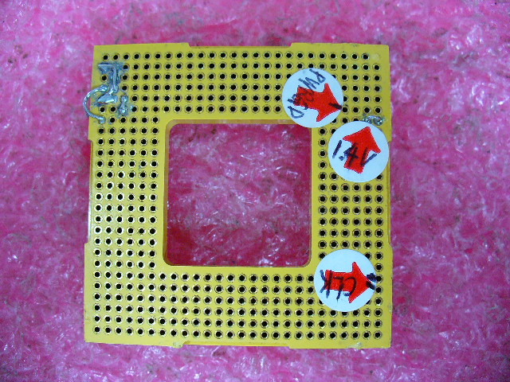
VID0 VID1 VID2 VID4 VID5 VID6 connected to GND
VID3 connected to VCCSENSE

P/N:22-T00433001
AMD 939
VID0,VID3,VID4 and GND short
CLK

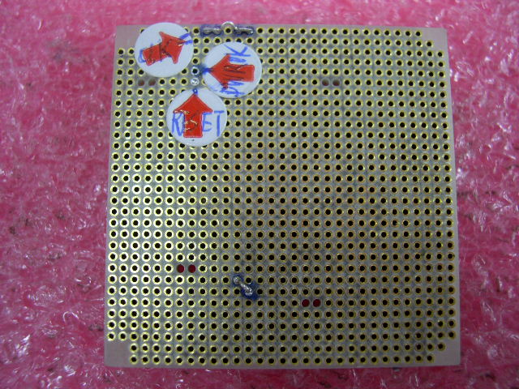
1.4V VCORE VDD and VDDIO_SENSE short
RESET
PWROK

Intel 775

P/N:08-900037600

CLK
CLK
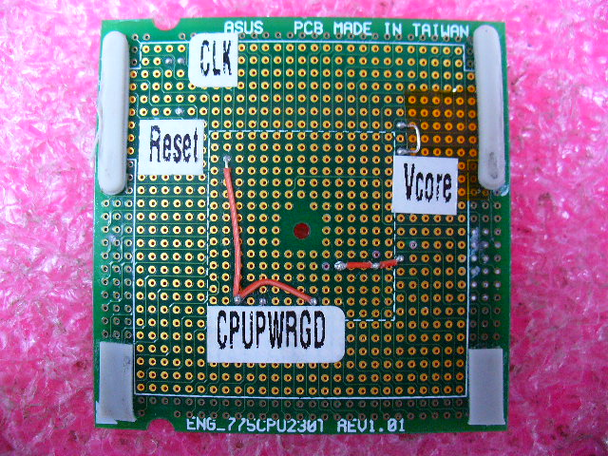
VID0 VID2 connected to GND
VTT_OUT_R VTT_OUT_L VTT_CPU short
RESET
OLD VCORE 1.2V
NEW VCORE 0.85V
PWRGD
VID7 connected to GND

AMD 940

P/N:22-060003360

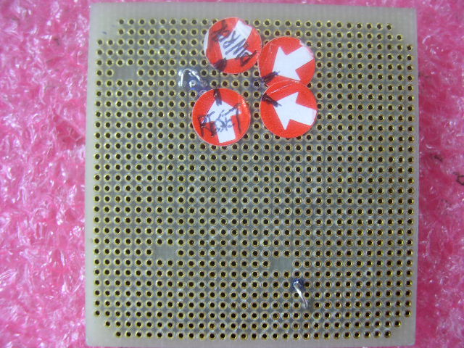
VID0,VID3,VID4 and GND short
RESET
PWROK
CLK
CLK
1.4V Vcore

AMD 754
P/N:22-060002720

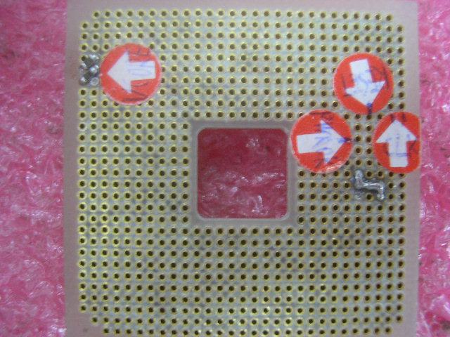
VID0,VID2,VID3,VID4 and GND short
RESET
PWROK
CLK
1.5V VCORE
ADD TWO 15 0hm
CLK

Intel 478
P/N:22-060001740
1.5V Vcore

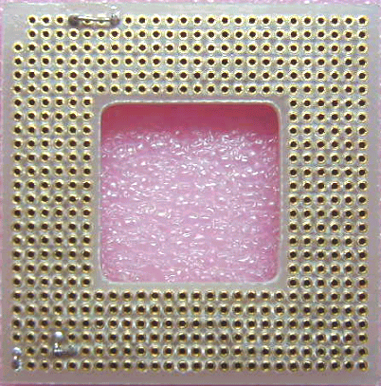

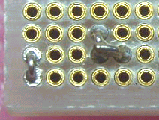

AMD 462

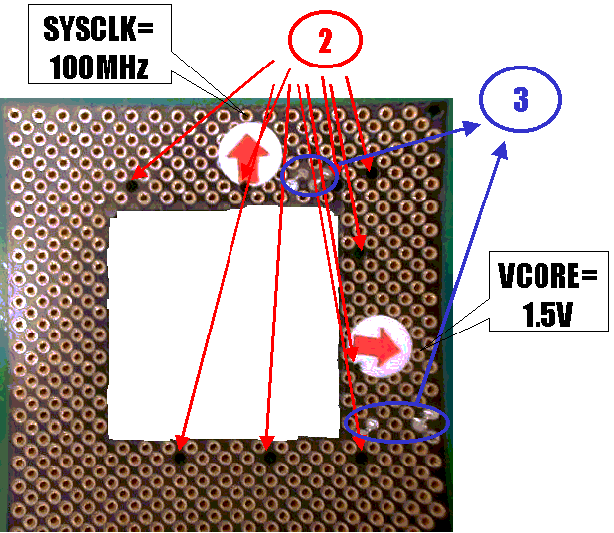

AM2
P/N:16-T10640704
1.8V DUAL

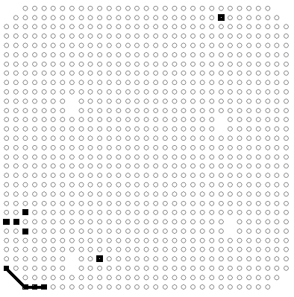
H_K8VID3 H_K8VID4 H_K8VID0 connected to GND
1.4V VCORD
RESET
PWROK
CLK
CLK

備註:如果SIO chip使用的是IT8716F BX版本 此治具開電後約四秒鐘會
自動斷電 此現象為正常 而在CX跟DX版本則不會有這問題

Authorize by |  | Review by |  | Originator  by | Richard

